

**GEOLOGICAL FIELD OF SALT RANGE DEPARTMENT OF GEOLOGY**  KHUDHSL KHAN KHATTAK UNIVERSITY KARAK

***FIELD REPORT***

*Department of geology*

* *Khushal khan khattak university of karak*
* ***SUBMITTIED BY***
* *Muhammad Sudais*

*Hazrat Usman*

*Muhammad Zeeshan*

*Muhammad Anas*

* ***UNDER THE SUPERVISION OF;***
* *Sir Nasim and Afrasiab*
* ***FIELD AREA***
* *Khwarra saltrang*
* ***DATE OF VISIT***
* ***25/11/2025***

Contant

Day 1

Day 2

Day 3

Day 4

# Acknowledgement

I, **Muhammad Sudais**, would like to express my sincere gratitude to my respected supervisors, **Afar Siab** and **Naseem Javed**, for their valuable guidance, continuous support, and professional supervision throughout the **Salt Range field** work and the successful completion of this report.

I am also highly thankful to all my respected teachers of  **Khushal Khan Khattak University, Karak**, for their encouragement, academic support, and valuable knowledge that greatly contributed to this field study.

Special thanks to my classmates and field partners for their cooperation, teamwork, and assistance during data collection.

Finally, I would like to express my deepest appreciation to my family for their constant encouragement, patience, and moral support, which made the successful completion of this report possible.

## **Abstract**

This field report presents the geological observations and findings of the **Salt Range field study** conducted as part of the academic requirements of **Khushal Khan Khattak University, Karak**. The main objective of this fieldwork was to understand the regional geology, stratigraphy, structure, and mineral resources of the Salt Range area.

During the field study, different rock units were examined in detail, including sedimentary formations such as sandstone, limestone, shale, and gypsum. Structural features like folds, faults, and joints were also observed and recorded. Special attention was given to the occurrence of rock salt and associated minerals, which are of great economic importance in this region.

Various field techniques were applied, including lithological identification, measurement of strike and dip, and preparation of geological sketches and field notes. The collected data helped in understanding the geological history and tectonic setting of the Salt Range.

This fieldwork greatly enhanced practical geological skills and provided clear insight into the stratigraphic sequence and economic potential of the Salt Range area.

Day first

Stop 1 : sakessor limestone

Lithology ass we osbserved on the field mostly it was massive creamish to gray limestone.

Nodules are prenest in it (1) limestone nodule (2) chert nodule: made of up sio2

Environment of deposition: marine

Fossils : forominifers

Age : Eocene

Contact : lower – nammal formation

upper _ chrgali formation

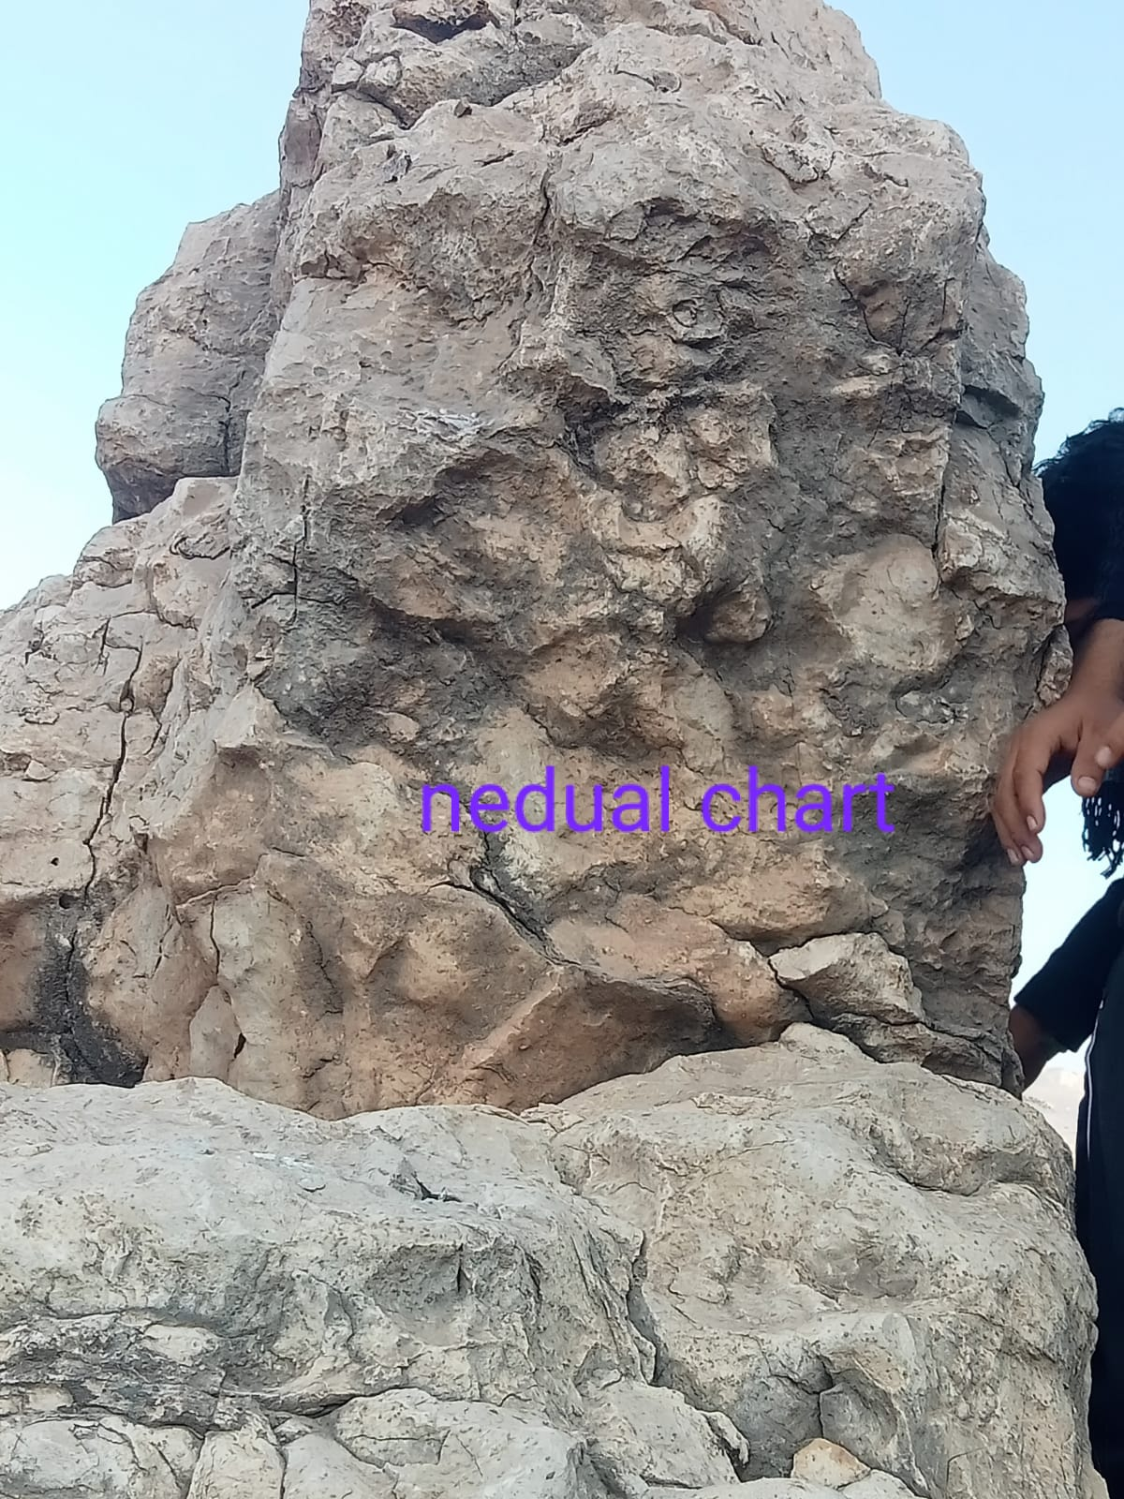

* Stop 2

Tobra formation

* Lithology

mostly its compared of conglomerate and braccia

It contain pink granit which the source of india.

Enviroment of deposition: glacial flouial environment

poorly sorted deposition due to immature flows.

Age : early permeain

Fossils : bivaluas and gastropods.

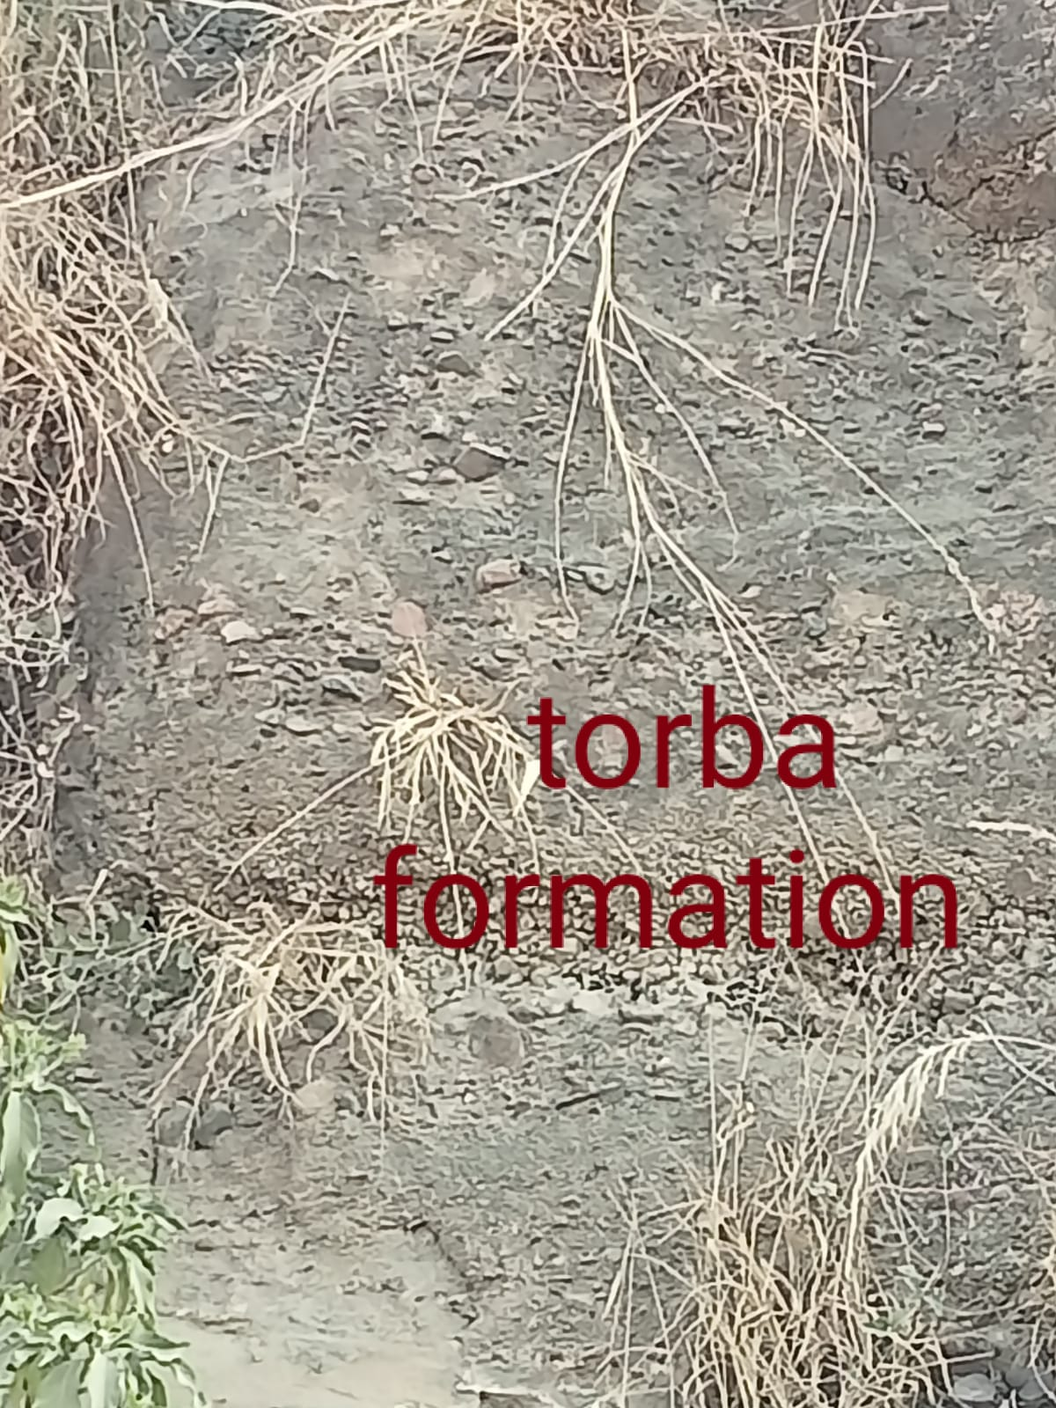Contact : lower contact of the tobra formation is widespread unconformity with khewra sandstone. The upper contact it (grudational) conformity with the dandot formation

* Stop 3
* dondot formation
* Lithology: the part observed by us was mostly vegetable.it consist of light-gray to olive green sandstone with accessional pebbly beds subordinate shale.
* Fossils: no
* Age :
* Contact: lower contact – dondot formation has a gradational contact with the underlyiny tobra formation .

upper contact : warcha formation.

* Enviroment of deposition: shallow marines

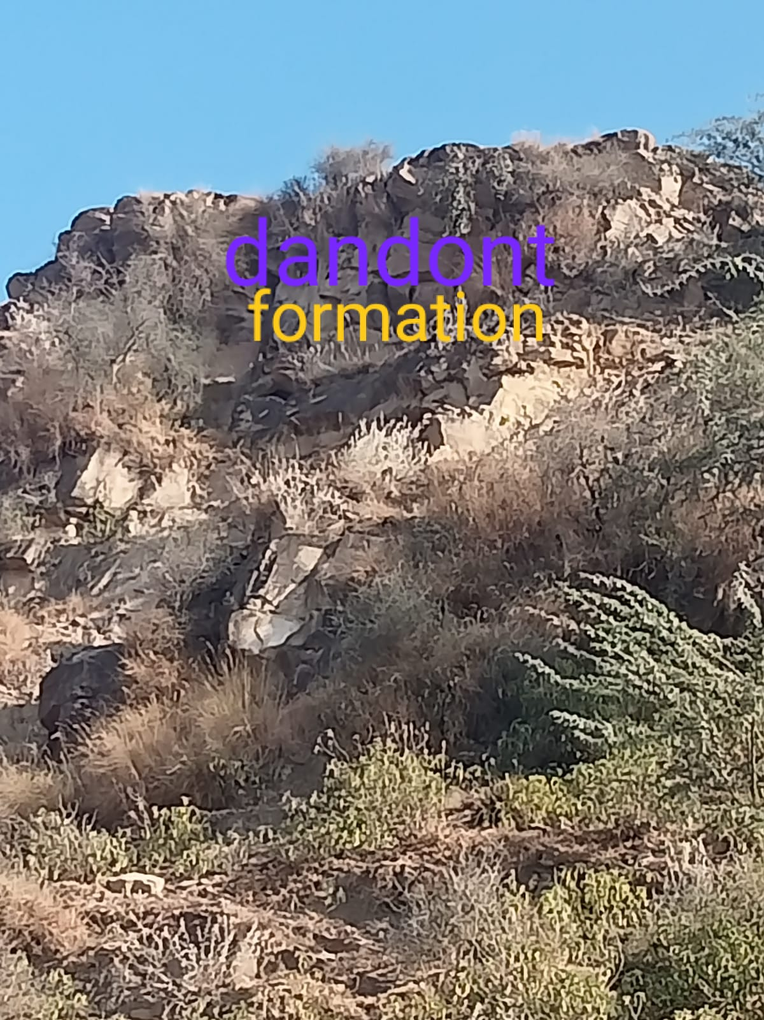

* Stop 4

***Salt rang formation***

* Lithology: it has three members.
* (1) Sahiwal marl member : it consist of red marl bed with salt seen thick bedded gypsum is also found.
* (2) Bandar kas gypsum member: consist of massive gypsum with some salt seem.also we find some minor bed of clay and dolomite in this member.
* (3) Billianwala member:

Fossile : it is devoid of fossils.

Age : Precambrian

contact : base of the formation is not expose anywhere including the study area.

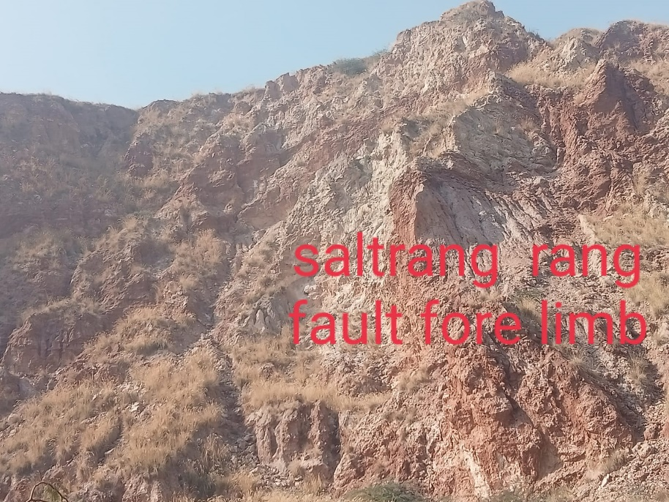 the upper contact is transitional with the khewra sandstone.

* Stop 5
* khewra formation
* Lithology : here the part of khewra sandstone we studied appeared to be .
* Fine texture, compact in form, maroonish in color, gave a smooth touch.
* Fossils: the khewra sandstone does not contain well-presweved fossils.
* Age :
* Contact : lower contact with salt rang formation
* upper contact: khussak formation both are conformablc
* Environment: of deposition dactaic of fluuial
* sedimentary structure: Ball and pillows structure.
* (1)cross bedding – indicates river tidal convet direction
* (2)Planer and trough cross-bedding: shows high energy depositon fro, flowing water.
* 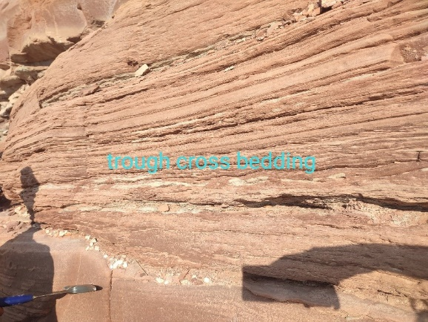(3) lenticular bedding.

Stope 6

Khussak formation

1. Lithology consist of shale and sandstone and siltstone
2. Color : variation due to gluconate mineral Green color due to gluconate mineral

Rick in sulfur.

3 : trace fossils.

Age :

Contact : lower – khewra formation

Upper – juttana formation

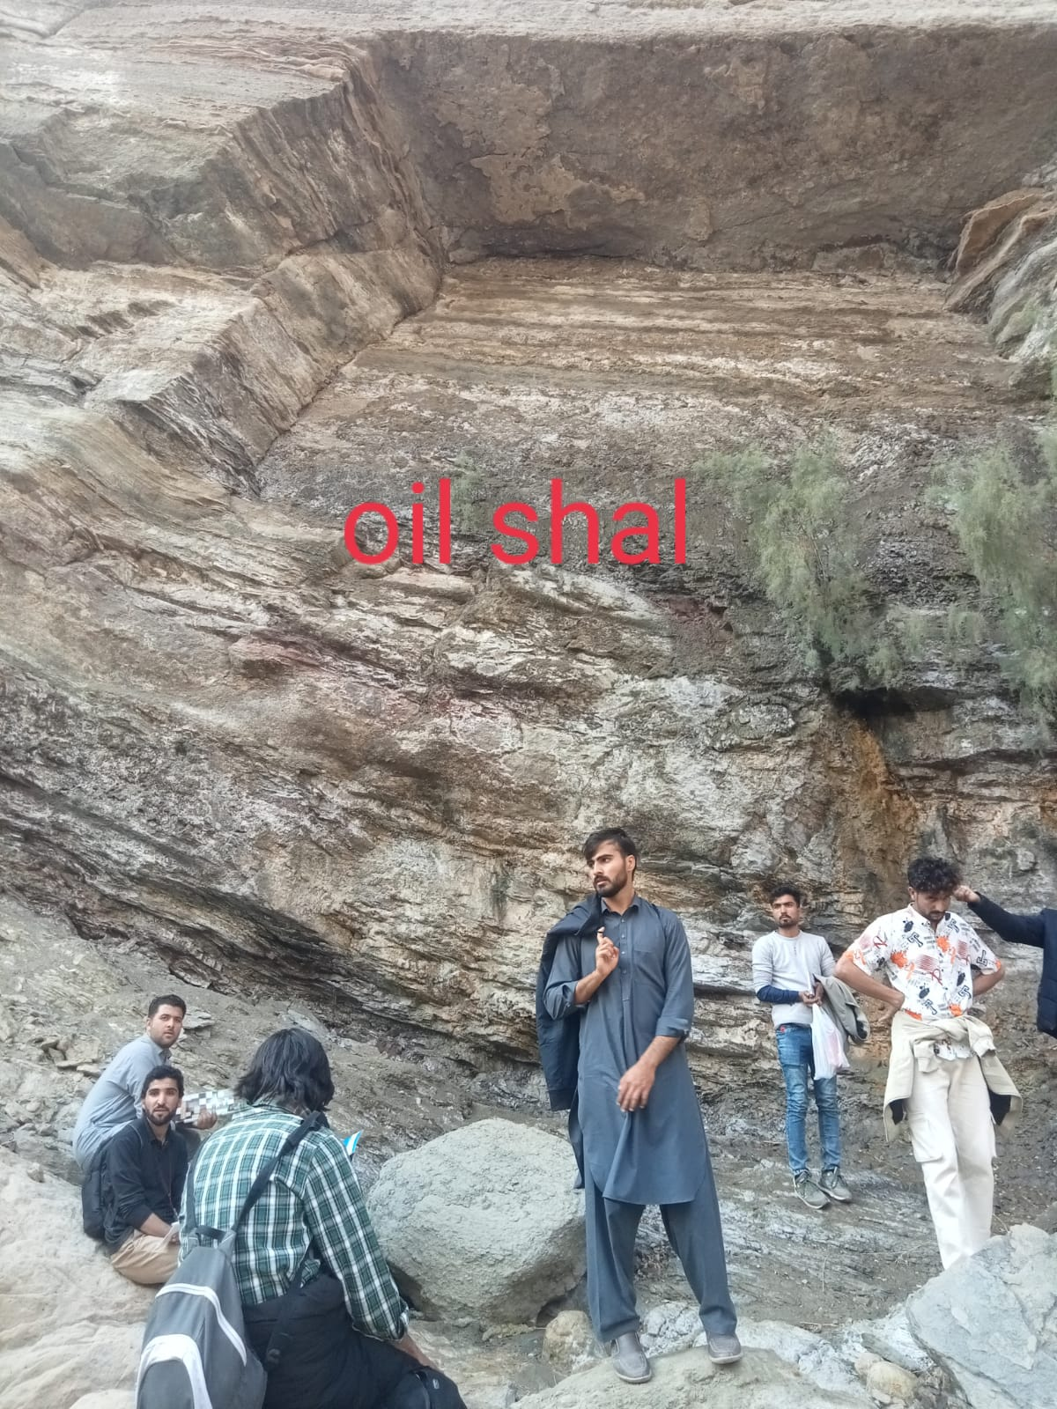Environment of deposition : shallow marine

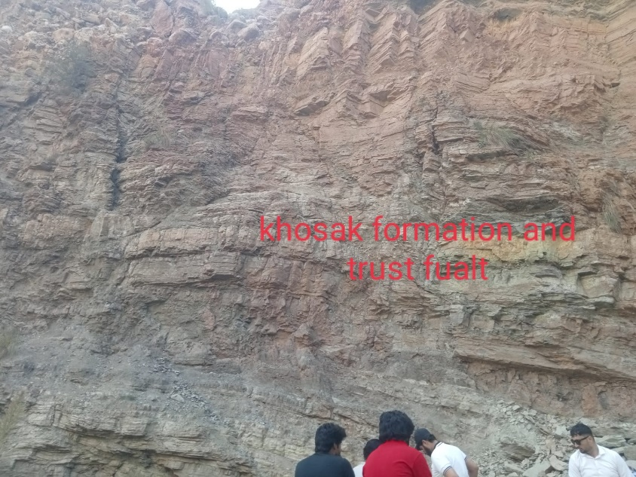

Stope 7

Juttana formation

Lithology : mostly primery dolominte

Also posses shale and sandstone

Fossils: the formation contain tracke and barrows of trilobite.

Age :

Contact : lower- khussak formation

Upper – baghawala formation

Environment f deposition : shallow marine .

Fornatal porosity

Contain primery dolominte.

stope 8

Baghawala formation

Lithology : composed of claystone mudstone and thin bedded flagy sandstone

Color : the flagy are purp;e and gray or blue green .

Fossils : no fossils .

Age : middle cambrain .

Contact : upper—tobra formation

Lower—juttana formation

Environment of deposition : lagonal with arid climate condition.

Second day

Nammal groge Weston saltrang

Wargal formation

**Wargal Limestone (Zaluch group)**

**Type locality:** Wargal village Central salt range.

**Age:** Late Permian.

**Lithology:** Nodular Limestone, Dolomite, Thin Sandstone Beds.

**Fossils:** Bivalves, Gastropods, Ammonoids.

**Features:** Nodularity, A black shale layer in the lowermost part, probably the contact with Amb formation.

**Contacts:** The upper contact is with conformable with Chidru formation, and the lower contact is not exposed in Namal gorge. But is appeared in other localities with Amb formation.

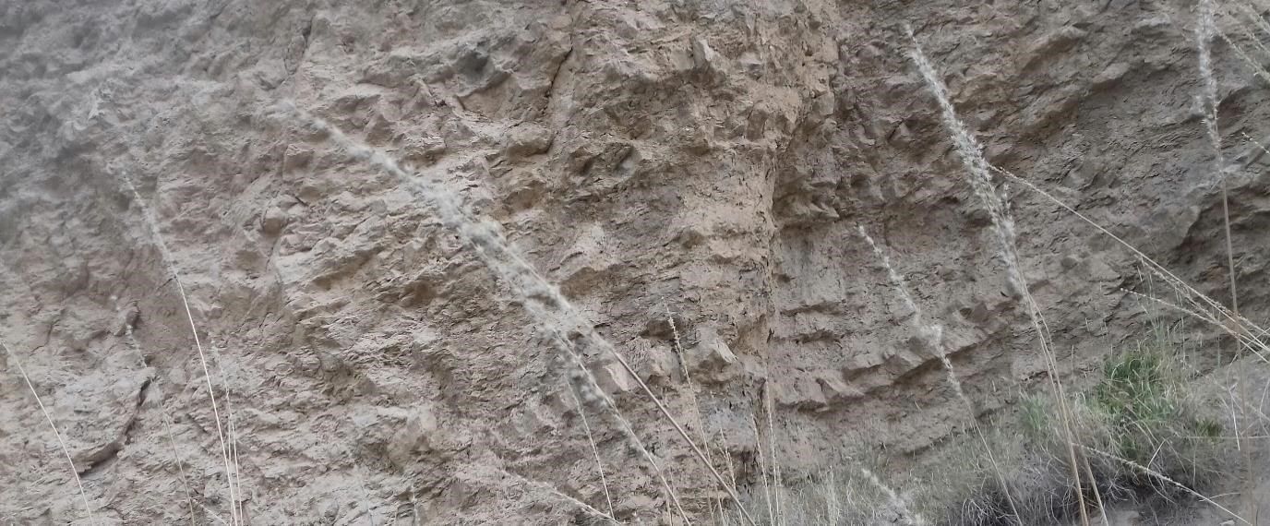

1. **Mianwali Formation (Musakhel group)**

**Type locality:** Zaluch Nala

**Age:** Triassic

**Lithology:** Mianwali formation have three members.

1. **Katwai member:** Consists of glauconitic limestone in the upper part and sandstone beds at the lower part.
2. **Mittiwali member:** Limestone beds in top and shale beds are at the bottom.
3. **Normia member:** Basal beds are of fragmental limestone and top portion consists of grey shale.

**Fossils:** Ammonites fossils are present in the Mittiwali member and brachiopods, and bivalves are present in the Normia member.

**Features:** Ceritide beds

**Contacts:** The lower contact is of Katwai member is with Chidru formation, marking the PT boundary and the upper contact is with the Tredian formation.

**3. Tredian Formation (Musakhel group)**

**Type locality:** Zaluch Nala

**Age:** Middle Triassic

**Lithology: The Tredian formation is composed of two members.**

**i. The Landa Member:** Composed of thick bedded sandstone, micaceous shale.ii. **The Khatkiara Member:** Thick, graded, white sandstone.

**Fossils: Microfossils are reported.**

**Features:**

**Contacts:** The lower contact is with Tredian formation, and the upper contact is conformable with Kingarali formation**.**

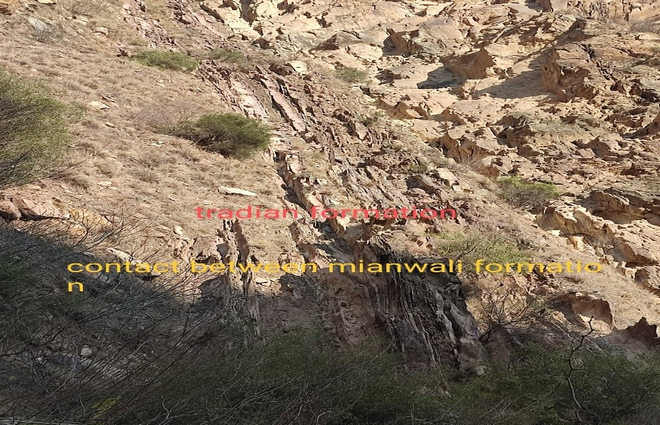

**5. Kingarali Formation (Musakhel group) Type locality:** Best exposed at Landa Nala.

**Age: Late Triassic**

**Lithology: Kingarali formation have two members.**

**i. Doya member:** Contain Dolomite, sandstone, and laterite bed. **ii. Vanjari member:** Consists of Dolomite and Marl.

**Fossils:** Bivalves and brachiopods are reported.

**Contacts:** The lower contact of Kingarali formation is conformable with Tredian and the upper contact is with Datta formation unconformably.

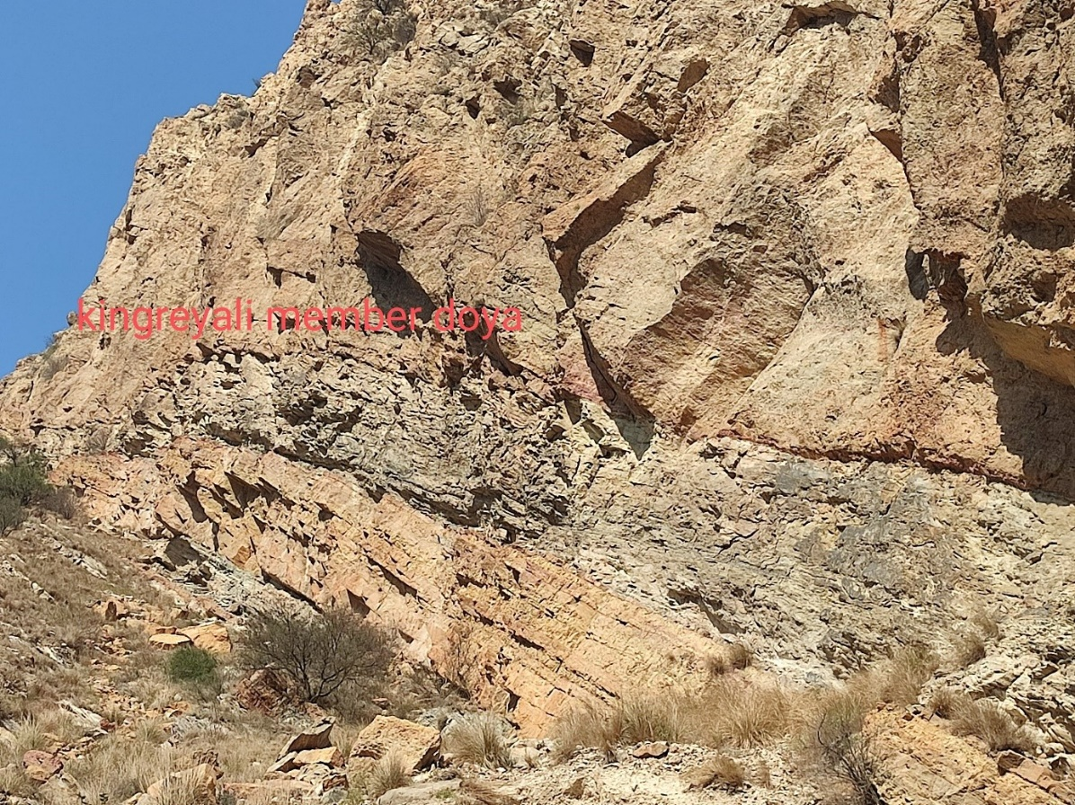

1. **Datta formation (Surghar group)**

**Type locality:** Datta Nala in Surghar ranges

**Age:** Early Jurassic

**Lithology:** Red Maroon Sandstone, Silt stone, Shale, Limestone, and thin beds of dolomite.

**Fossils:** Some carbonaceous remains are reported.

**Features:** Datta formation is know is petroleum system.

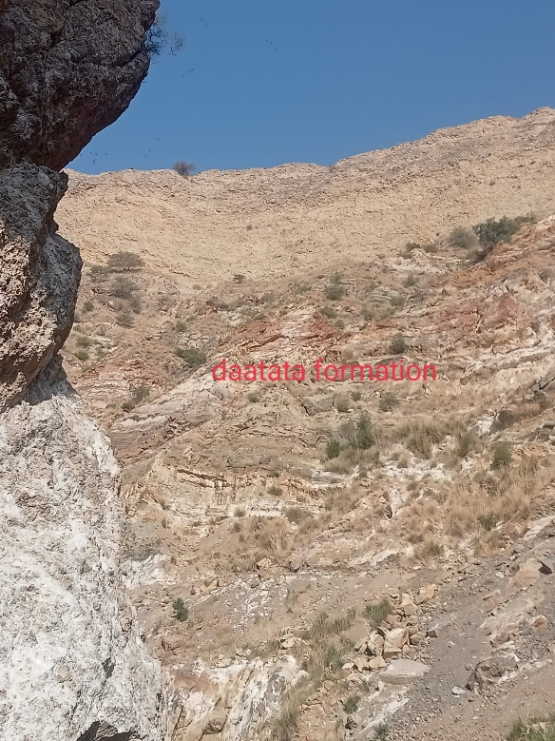**Contacts:** Lower contact is unconformable with Vanjari member of Kingarali formation, and the upper contact is conformable with Shinawri formation

1. **Samanasok (Surghar group)**

**Type locality:** Samanasok village

**Age:** Jurassic

**Lithology:** Thin to thick bedded marly nodular grey to brown limestone, grey to dark brown shale, ferruginous calcareous sandstone.

**Fossils:** No fossils founded

**Contacts:** The lower contact is with Samanasok formation unconformably, and the upper contact is conformable with Hangu Formation

1. **Hangu Formation (Makarwal group)**

**Type locality:** Hangu district Samanasok range.

**Age:** Early Pleocene

**Lithology:** Dark grey variegatedSandstone with interbedded carbonated shale and some nodular limestone.

**Fossils:** No fossils founded

**Features:** The sandstone is thick bedded at the top and thin bedded in the medal. And shale is in the lower part of the formation mostly.

**Contacts:** lower contact is with Hangu formation and upper is with Lockhart formation.

1. **Lockhart Formation (Makarwal group)**

**Type locality:** Near fort Lockhart in Samanasok range.

**Age:** Paleocene

**Lithology:** Massive beds of gray to white brecciated limestone.

**Fossils:** No fossils have been noticed.

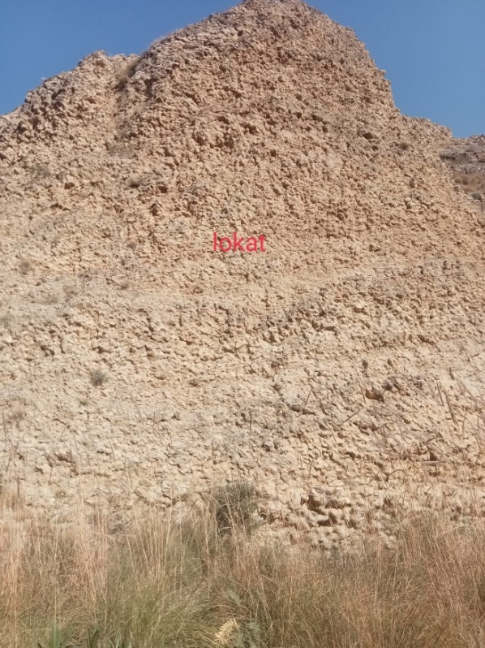**Contacts:** The lower contact is with Hangu formation, and the upper contact is with the Patala formation.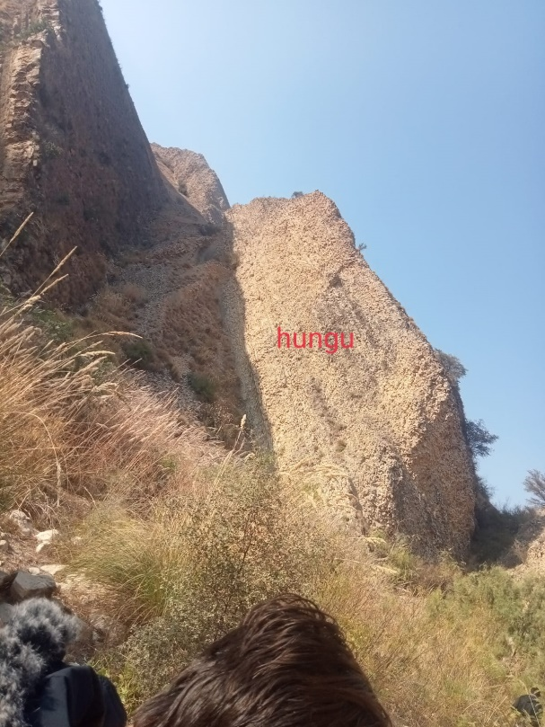

1. **Patala Formation (Makarwal group)**

**Type locality:** Patala Nala

**Age:** Paleocene

**Lithology:** Greenish greyShale, marl, subordinate interbedded nodular limestone, and sandstone in the upper part.

**Fossils:** Molluscs, foraminifera, and Ostracods.

**Contacts:** The lower contact is with Lockhart formation and the upper contact is with Namal formation. Both the contacts in the location are conformable

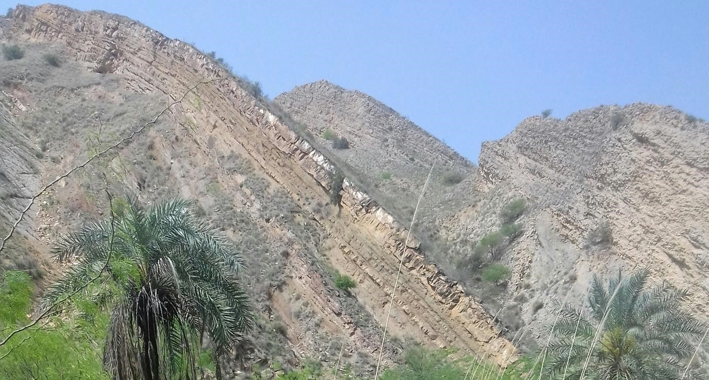

1. **Namal Formation (Charat group)**

**Type locality:** Namal gorge

**Age:** Eocene

**Lithology:** Thick bedded Alternation of grey shale, marl, and limestone.

**Fossils:** foraminifera and molluscs

**Contacts:** The lower contact is with Patala formation and the upper contact is with Sakesar formation.

## Zaluch Gorge (Day 3rd) 09/28/2025

1. **Salt Range Formation**

The Salt range formation is exposed in the very bottom of the mountain along the Zaluch Gorge. The two members The Sahiwal marl member belove and the Bandar kas Gypsum member above are highly weathered in this region. So, we scaped to the next formation above it.

1. **Tobra Formation (Nilawahan group) Type locality:** Near Tobra village.

**Age:** Permian

**Lithology:** Tillitic Conglomerate consists of clayey, sandy, silty Metrix and granite inclusions. The sandy part is brownish in bottom and reddish in middle, and the upper part is dark conglomerate.There are also some pink granite inclusions.

**Fossils:** Bivalves and ostracods are reported but not founded.

**Features:** Reversely graded (sediment size increase upward).

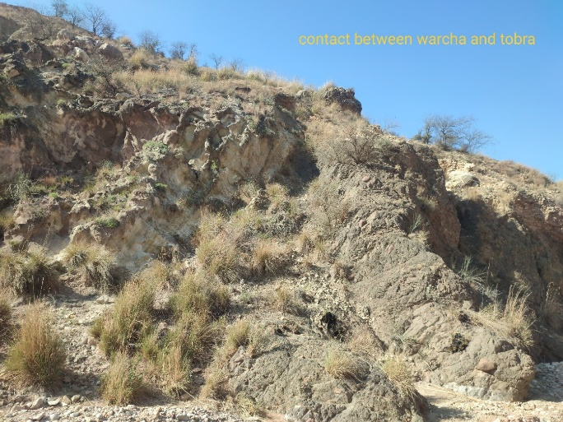**Contacts:** The lower contact is with salt range formation disconformable and the upper contact is with Warcha formation, which is conformable.

1. **Warcha Formation (Nilawahan group) Type locality:** Warcha gorge salt range.

**Age:** Permian

**Lithology:** Thick bedded reddish-purple sandstone and interbedded red shale and conglomerate of Coarser sand particle.

**Fossils:** No fossils founded

**Features:** Root casts, Angular unconformity between Warcha sandstone lower unit and recent conglomerate.

**Contacts:** The lower contact is with the Tobra formation unconformably and the upper contact is with Sardhai formation.

1. **Sardhai Formation (Nilawahan group) Type locality:** Sardhai gorge eastern salt range.

**Age:** Permian

**Lithology:** greenish grey thin bedded sandstone and siltstone, lavender color clay and dark carbonaceous shale beds.

**Fossils:** Some fish fossils are reported **Features:**

**Contacts:** The lower contact is with Warcha sandstone, and the upper contact is with Amb formation.

1. **Amb Formation (Zaluch group)**

**Type locality:** Amb village central salt range

**Age:** Permian

**Lithology:** Brownish grey thick beddedSandstone present in the lower part of the formation, Limestone is present in the top of the formation with interbedded shale.

**Fossils:** Fusilinids are present in the calcareous sandstone of Amb formation. Some brachiopods, Bivalves, bryozoans, and gastropods are also reported.

**Contacts:** The lower contact is with the Sardhai formation, and the upper contact is with the Wargal formation.

1. **Wargal Limestone (Zaluch group)**

**Type locality:** NearWargal village central salt range.

**Age:** Permian

**Lithology:** The Wargal formation comprise a missive succession of thick bedded darkish grey, cream color limestone and brecciated dolostone.

**Fossils:** Brachiopods, bivalves, gastropods, ammonites, and trilobite fossils are common in the formation

**Features:** Due to intense east west folding in the salt range the formation exposed is tilted near vertical.

**Contacts:** The lower contact is with Amb formation, and the upper contact is with the Chidru formation conformably.

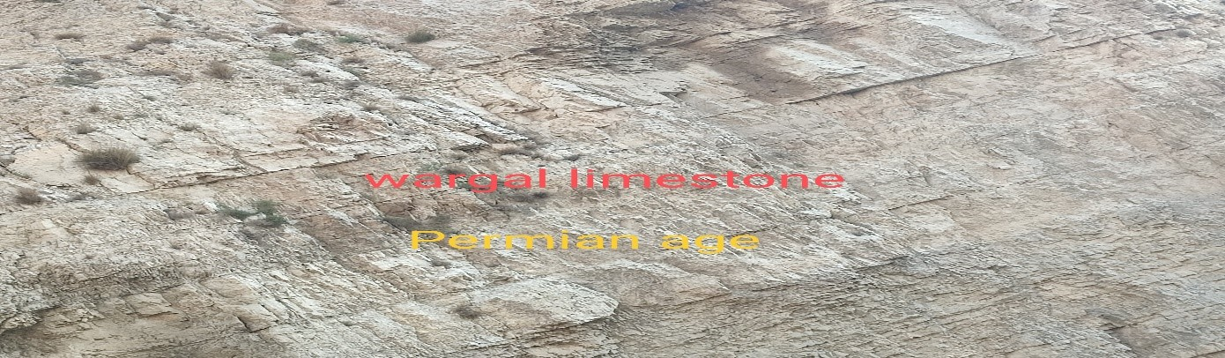

1. **Chidru Formation (Zaluch group)**

**Type locality:** Chidru village Mianwali district

**Age:** LatePermian

**Lithology:** white sandstone in the upper part,Sandy limestone, nodular limestone, calcareous limestone, and subordinate dark shale.

**Fossils:** Brachiopods

**Features:** Ripple marks in the sandstone beds

**Contacts:** The lower contact is with the Wargal limestone, and the upper contact is with the Katwai member of Mianwali formation of Triassic age marking the Permo-Triassic boundary as well.

Day 4 chchli groge 29/09/2025

Chingi Formation:(Chacli group) Type locality: chingi formation is south chinji village in Talagang District, punjab province,

Age: Late Miocene to early pliocene,

Lithology:Dominantly clay and sandston with minor silston. at the type locality the thickness is reported as about 750 m.

Fossils:mammal fossils.

2 : Sakesar Formation.

Type locality: sakesar peak in the central salt Range of Punjab, pakistan

Age:Early Eocene (paleogene).

Lithology:Dominantly limestone (light grey to cream colored) commonly nodular to massive , with subordinate marl.

Fossils: Rich in marine fossils foraminifera , mollusks, echinoids.

3: Namal Formation.

Type Locality: namal gorge in the western salt range , mianwali district,

Age: early Eocene.

Lithology: shale, marl, and limestone.

Fossils: (its got some cool marine ones!)

4: Patala Formation:

Type Locality: Patala Nala in the mianwali Distroct.

Age: Late paleocene.

Lithology:The formation consiste mainly os shale and marl with sobordinate limestone and sandston , some section contian coal seams.

Fossils: no fossil were foundded.

5: Lockhart Formation.

Type localioty: Lockhart formation near the kohat area.

Age: Late peleocene.

Lithology: it is the nodular limestone.

Fossils: shallow marine.

6: Hangu Formation:

Type Locality: hangu gorge of the kohat -potwar region.

Age: early paleocene.

Lithology: predominantly sandston with interbedded shale; also carbonaceous shale , coal seams, laterite, andrare limestone lenses.

Fossils:marine and terrestrial fossils.

# ****Murree Formation (Early–Middle Miocene)****

## ✅ Lithology

* Red to purple **sandstone**
* **Siltstone + mudstone**
* Shale / clay layers
* Local **conglomerate lenses**

## ✅ Grain Size

* Mostly **fine to medium sand**
* Mudstone dominant in many parts
* Some places **coarse sand** and pebbly beds

## ✅ Depositional Environment

* **Fluvial (river system)**
* Floodplain + channel deposits
* Mostly **meandering rivers** (slow moving)

## ✅ Contact

* Usually **conformable to gradational**
* Murree → Kamlial (transition from finer to coarser)

## ✅ Sedimentary Structures

* Cross bedding (small–medium scale)
* Ripple marks
* Mud cracks (locally)
* Burrows rare

## ✅ Bedding

* Thin to medium bedded
* Mudstone part laminated

## ✅ Dip / Strike (General)

* Strike: mostly **E–W**
* Dip: **N or S**, usually **moderate (20°–60°)** in folded zones

## ✅ Sequence Stratigraphy (Simple)

* Represents **continental molasse** due to Himalayan uplift
* **Upward coarsening trend** (more sand upward)
* Overall **progradational fluvial system**

# 2) ****Kamlial Formation (Middle Miocene)****

## ✅ Lithology

* Dominantly **sandstone**
* Grey to brown sandstone
* Minor mudstone/siltstone
* Conglomerate at base (some areas)

## ✅ Grain Size

* Mostly **medium to coarse sand**
* Pebbly sandstone common

## ✅ Depositional Environment

* **Braided river system**
* High energy channels
* Alluvial plain

## ✅ Contact

* Lower contact: **gradational** with Murree
* Upper contact: **gradational** into Chinji (sand → mud)

## ✅ Sedimentary Structures

* Large scale cross bedding
* Trough cross bedding
* Channel scours
* Imbrication in pebbles (locally)

## ✅ Bedding

* Thick bedded sandstone
* Multi-storey channel bodies

## ✅ Dip / Strike

* Strike E–W
* Dip moderate to steep in anticlines/synclines

## ✅ Sequence Stratigraphy

* **High sediment supply** (uplift)
* Channel stacking → **aggradation**
* Upward: decrease in energy toward Chinji

# 3) ****Chinji Formation (Middle–Late Miocene)****

## ✅ Lithology

* Dominantly **red mudstone**
* Siltstone
* Fine sandstone interbeds
* Calcareous nodules common

## ✅ Grain Size

* Mostly **clay + silt**
* Sandstone: **fine**

## ✅ Depositional Environment

* **Floodplain deposits**
* Overbank muds
* Small meandering channels
* Soil formation (paleosols)

## ✅ Contact

* Lower: gradational from Kamlial (sand decreases)
* Upper: gradational to Nagri (sand increases)

## ✅ Sedimentary Structures

* Laminations in siltstone
* Mud cracks
* Root traces
* Burrows (rare)

## ✅ Bedding

* Thin bedded
* Mudstone massive to weakly laminated

## ✅ Dip / Strike

* Same regional trend

## ✅ Sequence Stratigraphy

* Represents **low-energy floodplain phase**
* **Maximum floodplain development**
* Often interpreted as more stable conditions / less channel dominance

# 4) ****Nagri Formation (Late Miocene)****

## ✅ Lithology

* Dominantly **sandstone**
* Grey to brown sandstone
* Conglomerate lenses
* Mudstone minor

## ✅ Grain Size

* Medium to coarse sandstone
* Pebbly sandstone common
* Conglomerate: pebble size

## ✅ Depositional Environment

* **Braided river**
* High discharge rivers
* Channel dominated system

## ✅ Contact

* Gradational from Chinji (mud → sand)
* Gradational to Dhok Pathan (sand decreases upward)

## ✅ Sedimentary Structures

* Large trough cross bedding
* Planar cross bedding
* Channel scours
* Gravel bar structures

## ✅ Bedding

* Thick bedded, multi-storey sandstone bodies

## ✅ Dip / Strike

* E–W strike, moderate dip

## ✅ Sequence Stratigraphy

* **Coarsening upward system**
* More uplift + sediment supply
* Channel stacking suggests **high accommodation + high supply**

# 5) ****Dhok Pathan Formation (Late Miocene–Pliocene)****

## ✅ Lithology

* Alternating **sandstone + mudstone**
* Siltstone
* Conglomerate beds common
* More heterogeneous than Nagri

## ✅ Grain Size

* Sand: fine to coarse
* Conglomerate: pebble to cobble
* Mud: clay/silt

## ✅ Depositional Environment

* **Fluvial system**
* Mix of braided + meandering
* Floodplain + channel deposits both strong
* Alluvial fan influence locally

## ✅ Contact

* Lower: gradational from Nagri
* Upper: gradational into Soan Formation (more conglomerate)

## ✅ Sedimentary Structures

* Cross bedding
* Ripple marks
* Channel lag deposits
* Mud cracks in floodplain units

## ✅ Bedding

* Medium to thick bedded sandstone
* Mudstone intervals thick

## ✅ Dip / Strike

* Same Potwar fold belt trend

## ✅ Sequence Stratigraphy

* **Alternating sand–mud cycles** = channel migration + avulsion
* Upward trend toward **coarser gravel** (approaching Soan)

# 6) ****Soan Formation (Pliocene–Pleistocene)****

(Soon bolte hain but standard name ***Soan Formation*** hai)

## ✅ Lithology

* Dominantly **conglomerate**
* Sandstone interbeds
* Silt/mud minor

## ✅ Grain Size

* Pebble to cobble conglomerate
* Coarse sand

## ✅ Depositional Environment

* **Alluvial fan + braided river**
* Very high energy
* Near mountain front deposits

## ✅ Contact

* Gradational from Dhok Pathan (more gravel upward)
* Upper: often unconformable / recent alluvium

## ✅ Sedimentary Structures

* Clast imbrication
* Massive conglomerate beds
* Planar bedding in gravel bars
* Channel scours

## ✅ Bedding

* Thick bedded to massive
* Poor sorting common

## ✅ Dip / Strike

* In many areas dips moderate; near active folds dips steep

## ✅ Sequence Stratigraphy

* Represents **maximum uplift / molasse climax**
* Strong **progradation** toward foreland basin
* Upward: increasing coarse clastics = tectonic pulse